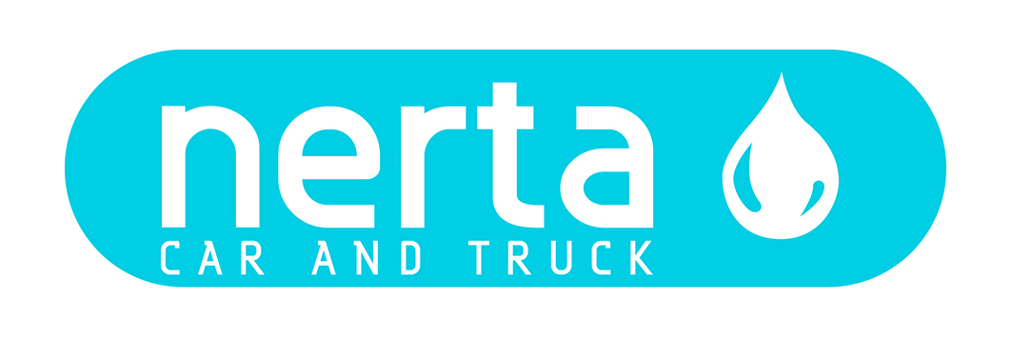

NERTA ANTI-INSECT

NERTA ANTI-INSECT is a unique, light alkaline detergent to remove dead insects from cars.

INSTRUCTIONS FOR USE
Can be used with fogging systems (10%), foam systems, in foam arches from carwash installations (1%) and as prewash agent in high pressure cleaners (1%).

TECHNICAL SPECIFICATIONS
Product code : ENT-000412
Colour : Brown
Fragrance : Terpene-like
Foam intensity* :
pH 100 % : 13 ± 0,5
pH 1 % : 10,5 ± 0,5
Dosage : 1 – 5 %
Biodegradability of surfactants : > 90 %
Packaging : 5 – 25 – 200 –1000 L
Specific gravity : 1,08 kg/L ± 1%

ENVIRONMENTAL INFORMATION
The surfactants in this product meet the criteria for biodegradability as established in Regulation (EG) n° 648/2004 concerning detergents.

SAFE HANDLING AND STORAGE
The complete safety instructions of the product can be found on the material safety data sheet.
Only for professional users/specialists.

Keep the product in the original and closed packaging and protect from extreme temperatures.

^{(*)} very weak weak fair strong very strong

