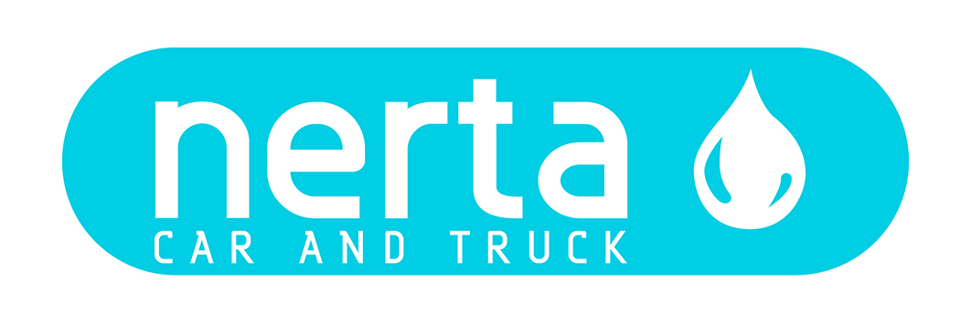

NERTA BRILLIANT HOT FINISH

NERTA BRILLIANT HOT FINISH is a concentrated drying aid with wax action for use at high and low temperatures (15-70°C). Gives a fast drying, preservative and glowing effect to the coachwork.

Instructions for use
10 - 20 ml per car. Avoid overdosing.

Technical specifications
Product code : ENT-001122
Colour : Bleu
Fragrance : Characteristic
Foam Intensity* : na
pH 100 % : 6,5 ± 1
Dosage : 10 – 25 ml
Biodegradability of surfactants : > 90 %
Packaging : 5 – 25 – 200– 1000 L
Specific gravity : 0,975 kg/L ± 1%

ENVIRONMENTAL INFORMATION
The surfactants in this product meet the criteria for biodegradability as established in Regulation (EG) n° 648/2004 concerning detergents.

SAFE HANDLING AND STORAGE
The complete safety instructions of the product can be find on the material safety data sheet.
Only for professional users/specialists.

Keep the product in the original and closed packaging and protect from extreme temperatures.

^{(*)} very weak weak fair strong very strong

