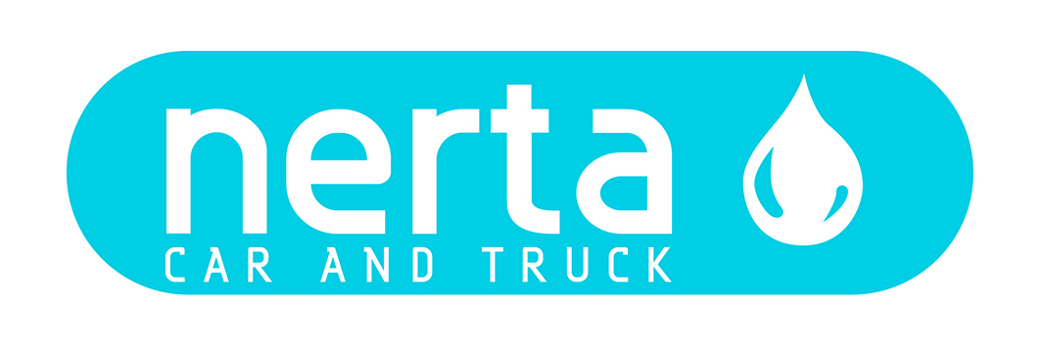

NERTA MOTOR CLEANER

NERTA MOTOR CLEANER is a powerful, strong alkaline cleaning agent, based on potassium hydroxide to degrease motors and all other parts which are covered with grease and dirt. Especially recommended for use in high pressure cleaners and spray appliances.

TECHNICAL SPECIFICATIONS
10-25%. Let it soak in, then rinse or steam off.

TECHNICAL SPECIFICATIONS
Product code : ENT-841002
Colour : Brown
Fragrance : Characteristic
Foam Intensity* :
pH 1 % : 11,50 ± 0,5
Dosage : 10 – 25 %
Biodegradability of surfactants : > 90 %
Packaging : 5 – 25 – 200 – 1000 L
Specific gravity : 1,130 kg/L ± 1%

ENVIRONMENTAL INFORMATION
The surfactants in this product meet the criteria for biodegradability as established in Regulation (EG) n° 648/2004 concerning detergents.

SAFE HANDLING AND STORAGE
The complete safety instructions of the product can be find on the material safety data sheet.
Only for professional users/specialists.

Keep the product in the original and closed packaging and protect from extreme temperatures.

^{(*)} very weak weak fair strong very strong

