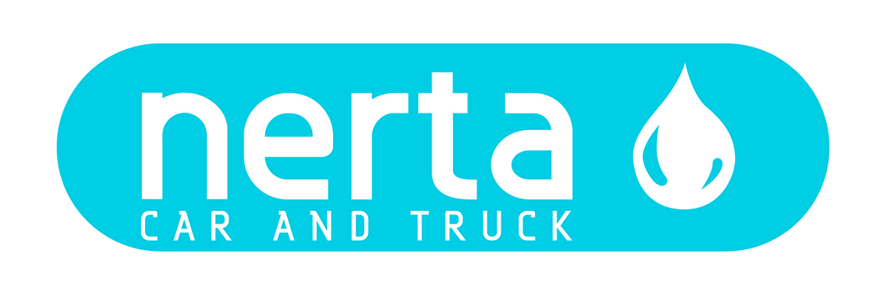

NERTA SKY WE64

NERTA SKY WE 64 is a light alkaline, nano-molecular and strongly concentrated prewash agent to clean all types of cars. Fills up the micropores of the coach work. Contains molecules which put a shining, dirt-repellent film on the lacquer. Easy to rinse. Removes insects. Freshly perfumed.

INSTRUCTIONS FOR USE
Can be used with spray systems, high pressure cleaners and foam systems.

TECHNICAL SPECIFICATIONS
Product code : ENT-100326
Colour : Orange
Fragrance : Citrus fruit
Foam intensity* :
pH 100 % : 13 ± 0,5
pH 1 % : 11 ± 0,5
Dosage : 1 – 5 %
Biodegradability of surfactants : > 90 %
Packaging : 5 – 25 – 200 – 1000 L
Specific gravity : 1,100 kg/L ± 1%

ENVIRONMENTAL INFORMATION
The surfactants in this product meet the criteria for biodegradability as established in Regulation (EG) n° 648/2004 concerning detergents.

SAFE HANDLING AND STORAGE
The complete safety instructions of the product can be find on the material safety data sheet.
Only for professional users/specialists.

Keep the product in the original and closed packaging and protect from extreme temperatures.

